* **Project Phase - IV - Develop a Web Application using frontend stack**

**“Online-Test-Application-Quiz “**

**This Project is developed by Siddhant Mhatre. This project is hosted on the git repository:**

**[https://github.com/Mscitsid/Online-Test-Application-Quiz.git]( https://github.com/Mscitsid/Online-Test-Application-Quiz.git)**

* **PROJECT DESCRIPTION -**

The Online Test Application system creates an application that enables users to provide online tests,review them, and display the results.

* **Screenshots of all Scenarios in the Application -**
* **Home Page Contains Quiz options user can take: (There are three quiz options now JavaScript, Asp.Net and C# (C Sharp)).**

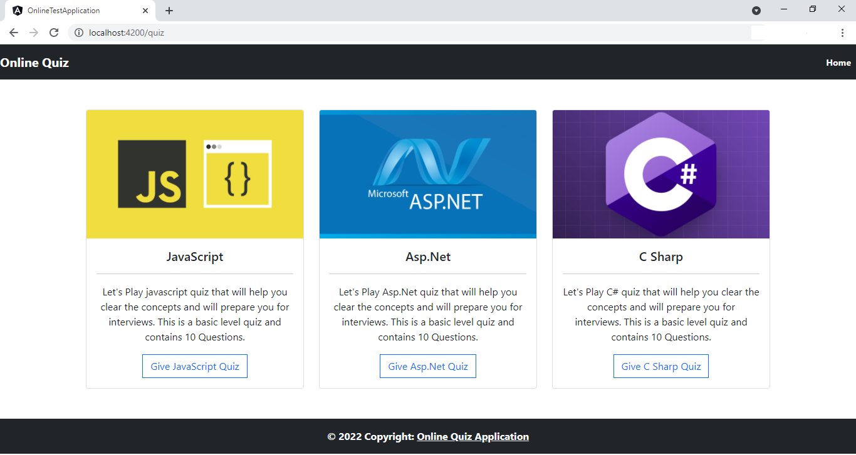

**The Quiz Names and Description are fetched dynamically using JSON data (Containing Questions and Answers) and Angular Framework.**

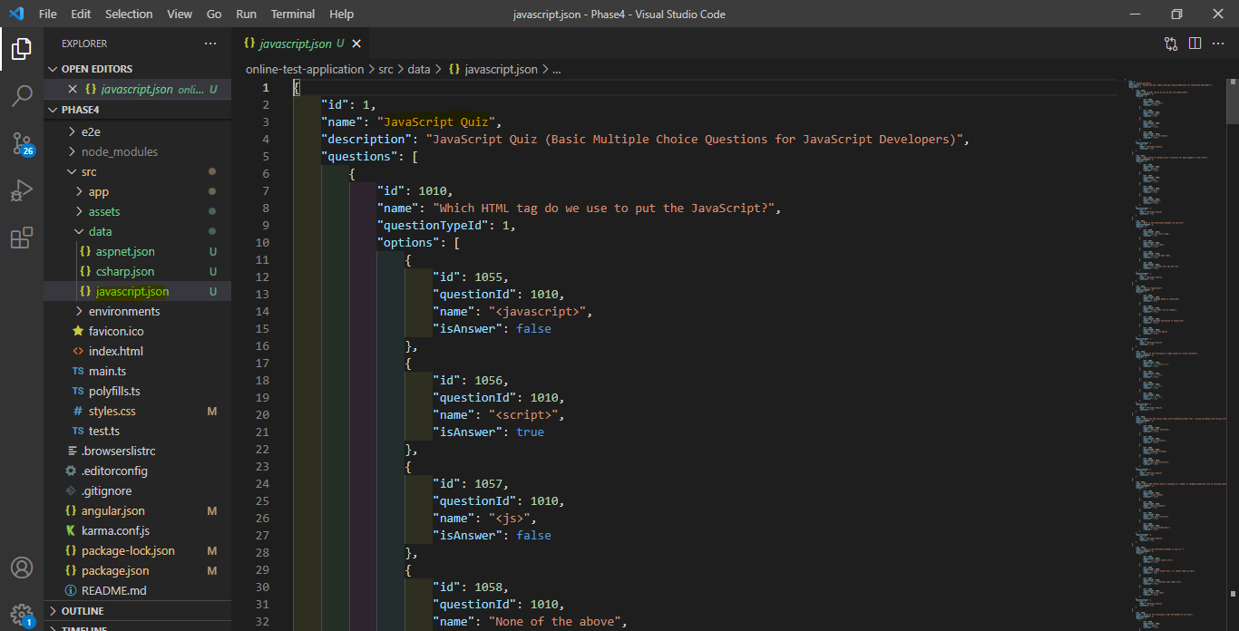

1. **When User Selects JavaScript Quiz, they are redirected to JavaScript quiz page where they can see all the questions with their options rendered from JSON file.**

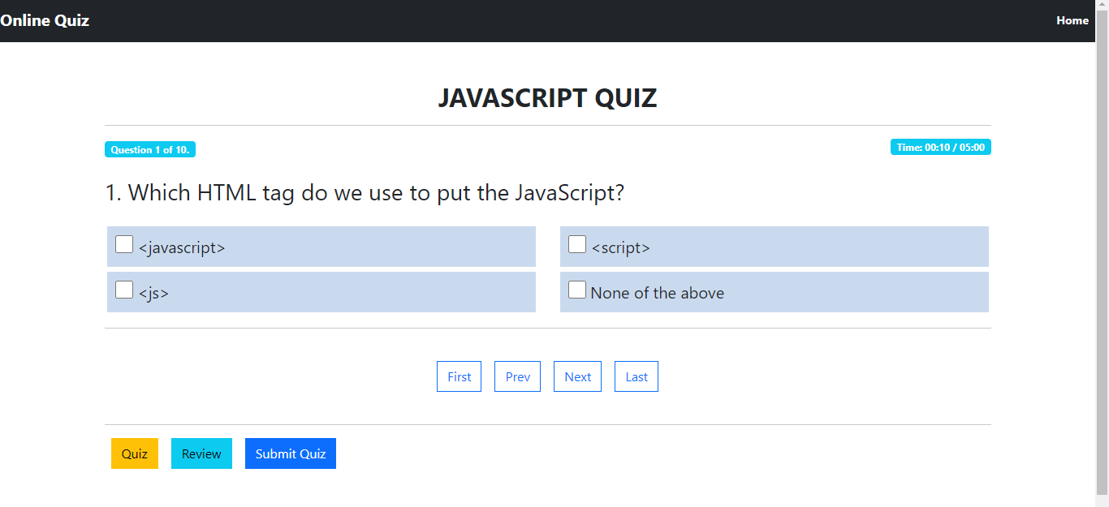

**User also have the option to navigate through questions using navigation links (First, Last, Prev and Next). There is also timer for quiz, after completion of allotted time the quiz submits automatically or User can submit their quiz before time using Submit Quiz button.**

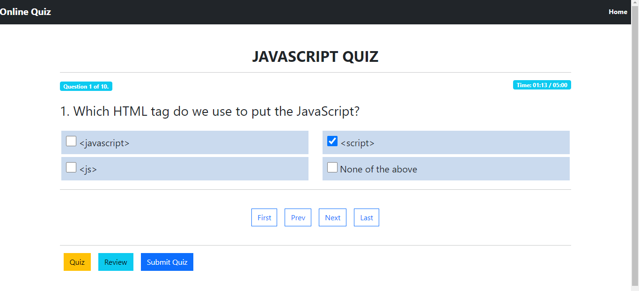

**User can select an option for the question and move to next question by clicking next navigation button**

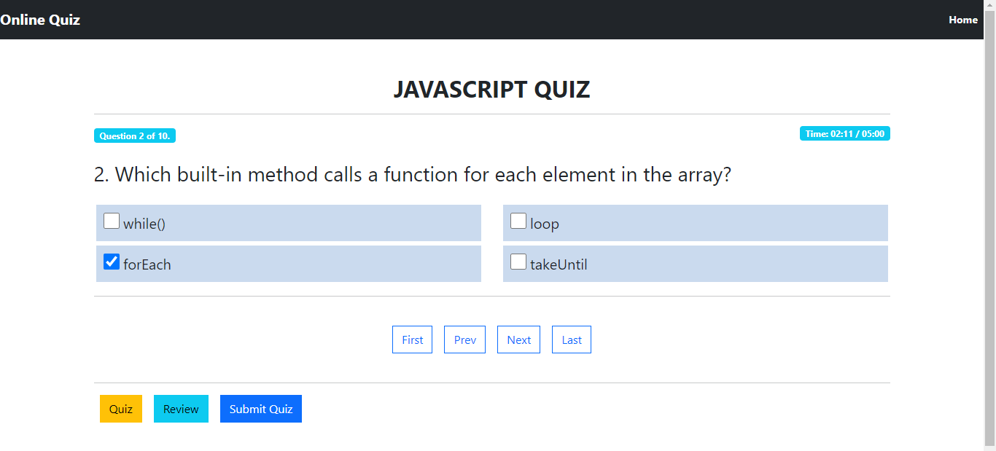

**Similarly, User can Answer all the questions asked**

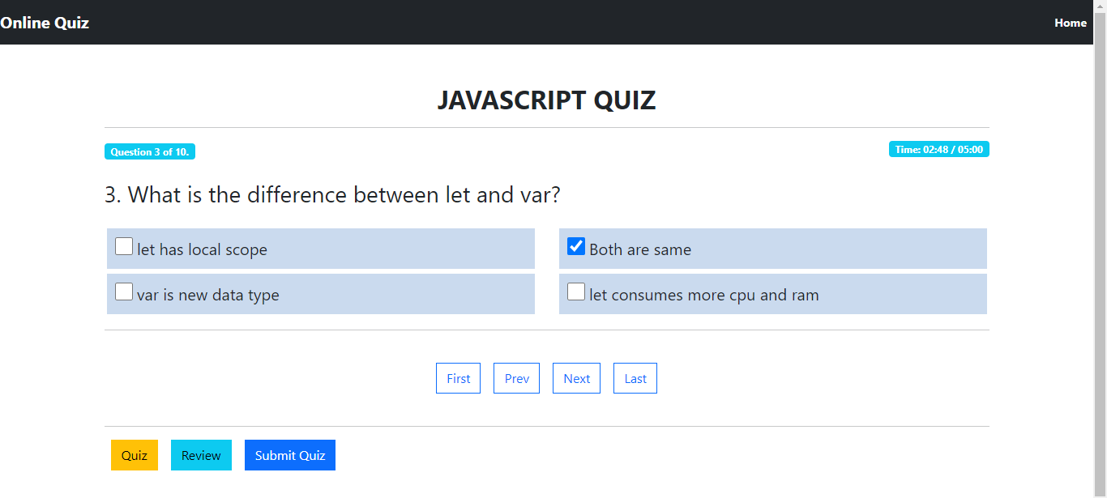

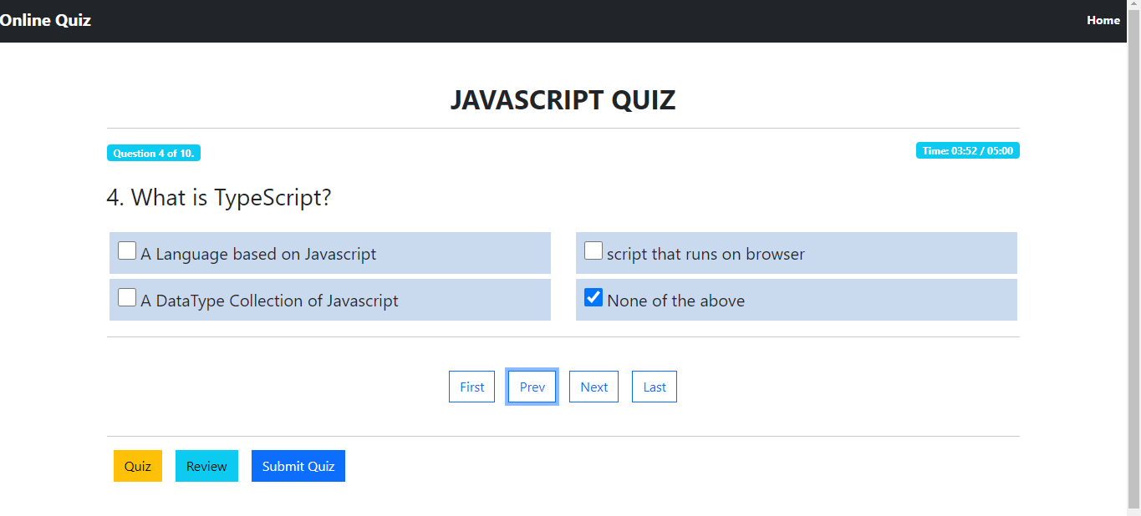

**User can also navigate to last or First question directly from First and Last Nav Links**

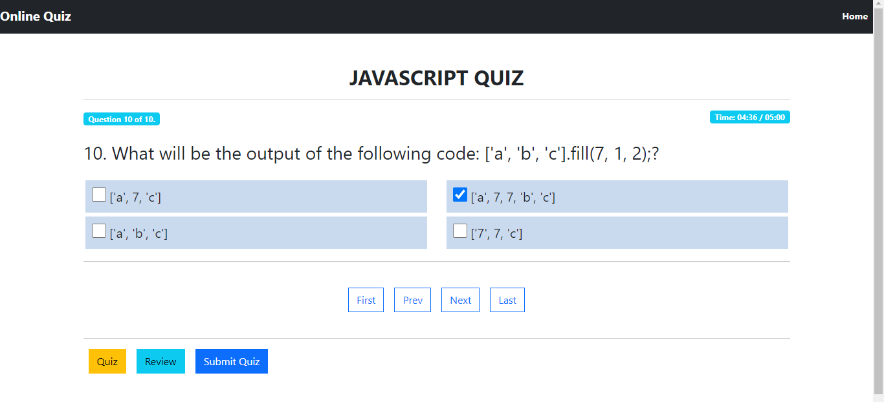

**User can Review All the Answered and Not Answered Questions by Clicking on Review Nav Link.**

**Also, user can go to specific question to answer by clicking on any of the Question Blocks.**

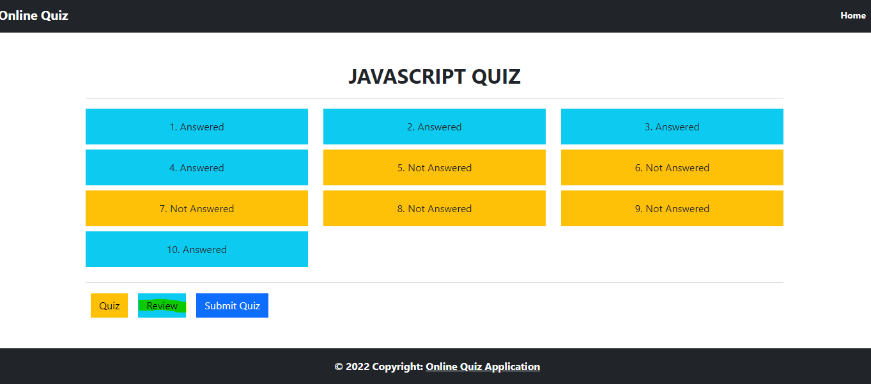

**User wanted to answer the 5th Not Answered Question:**

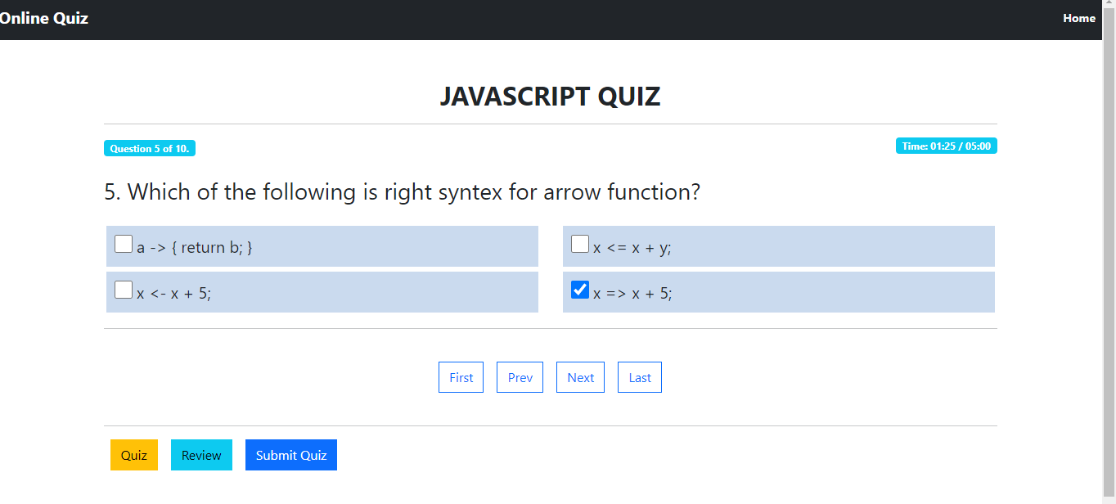

**Now we can see the 5th Question is marked as Answered:**

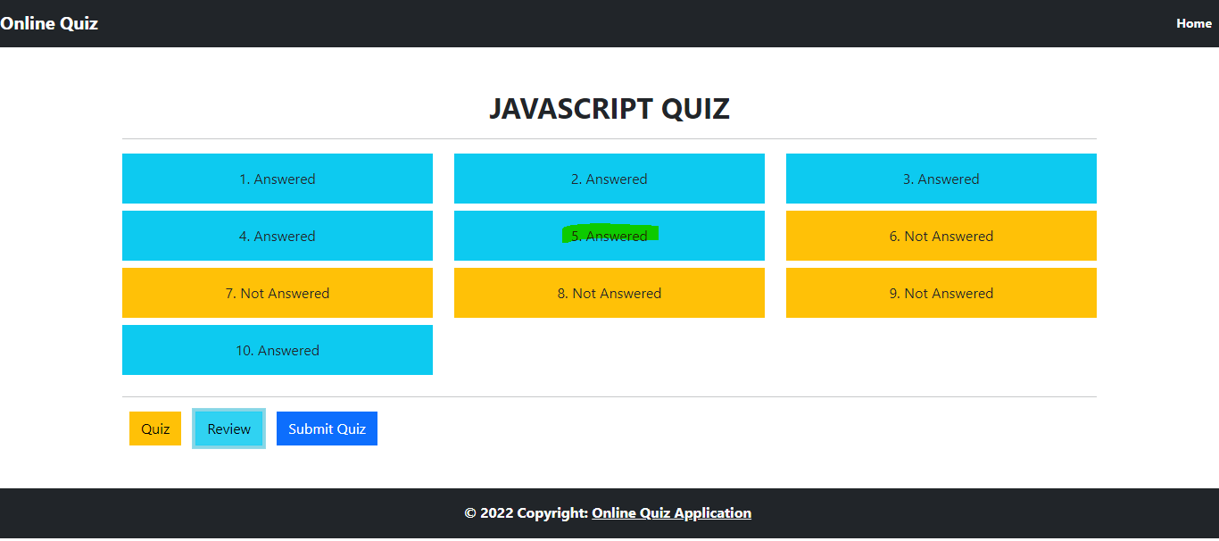

**When The user clicks on Submit button, they can see their result along with Questions and Options they have selected:**

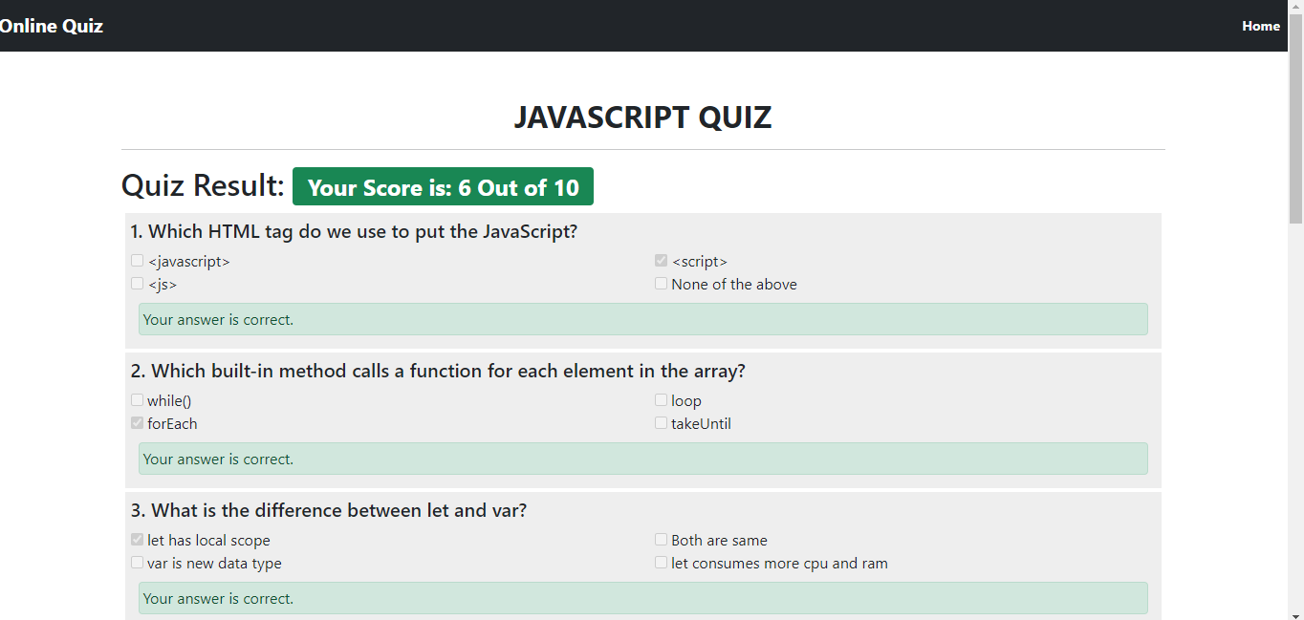

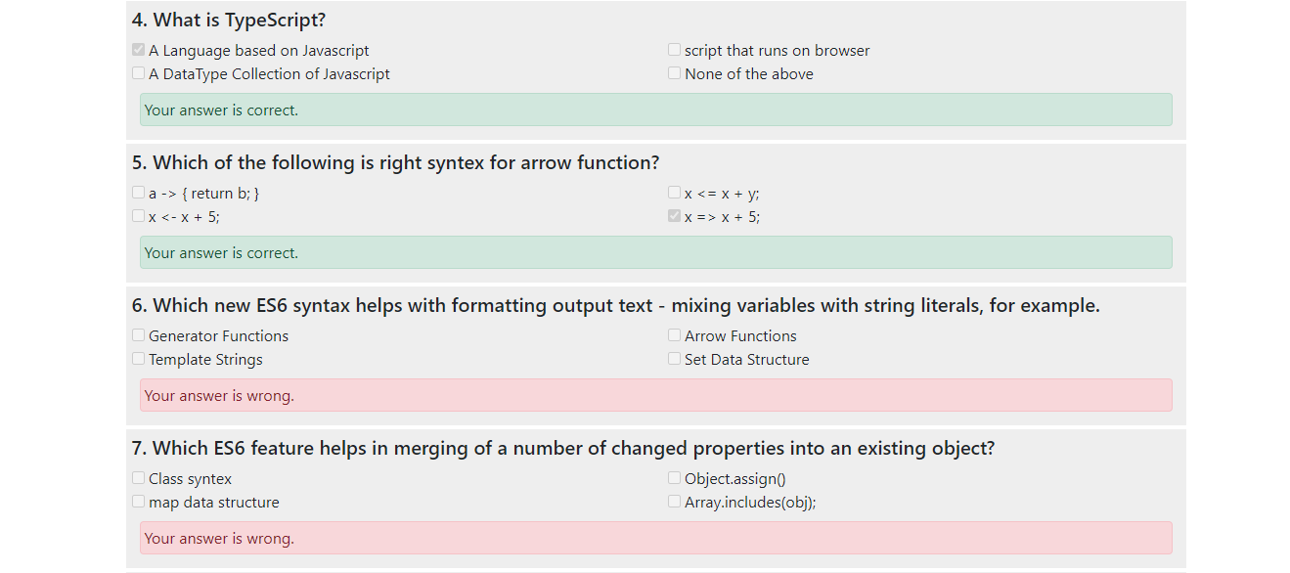

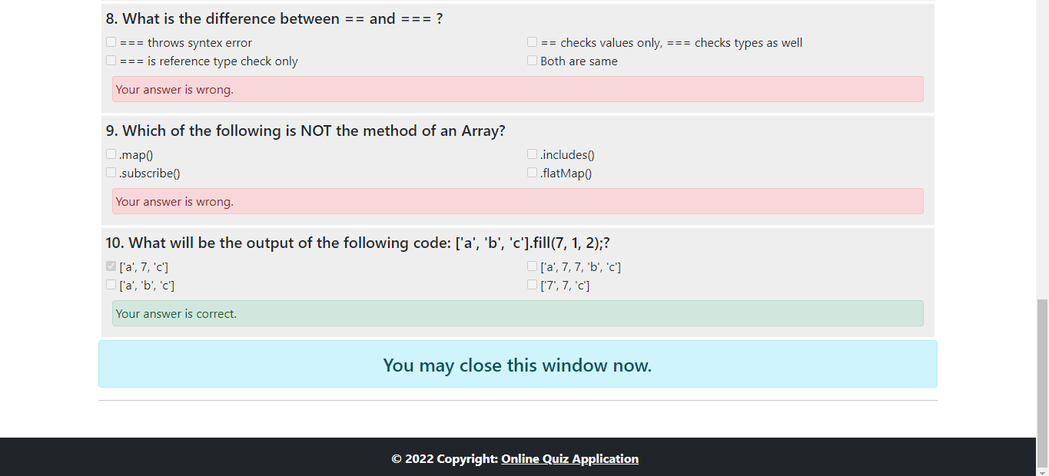

1. **User Selects to give Asp.Net Quiz**

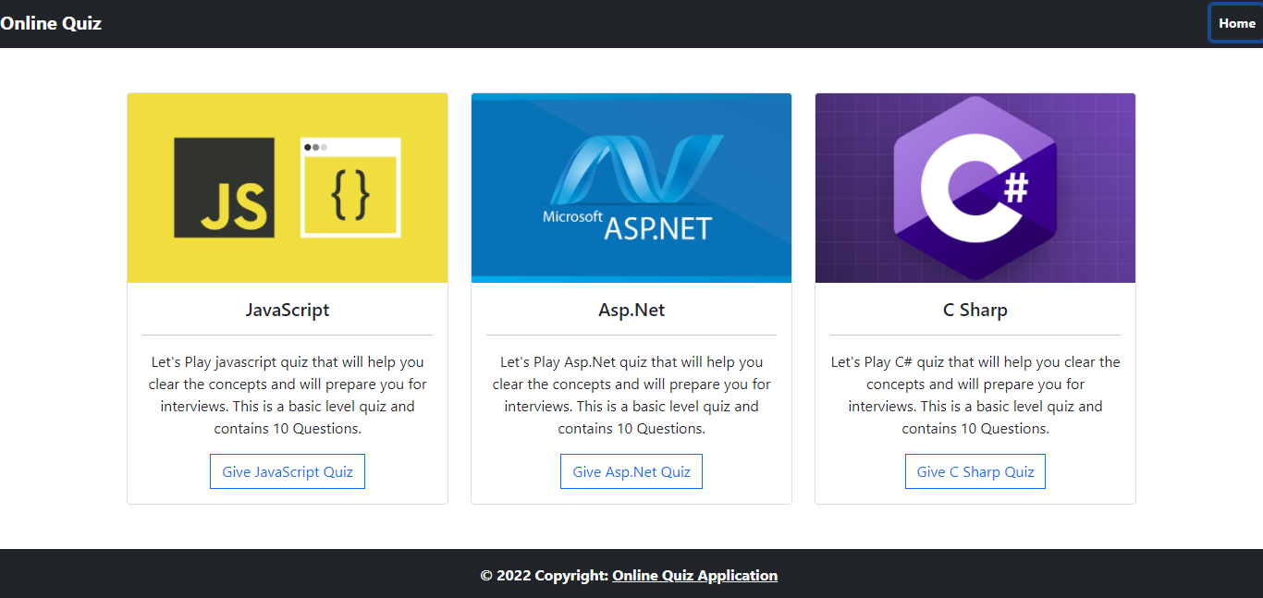

**When User Selects Asp.Net Quiz, they are redirected to Asp.Net quiz page where they can see all the questions with their options rendered from JSON file.**

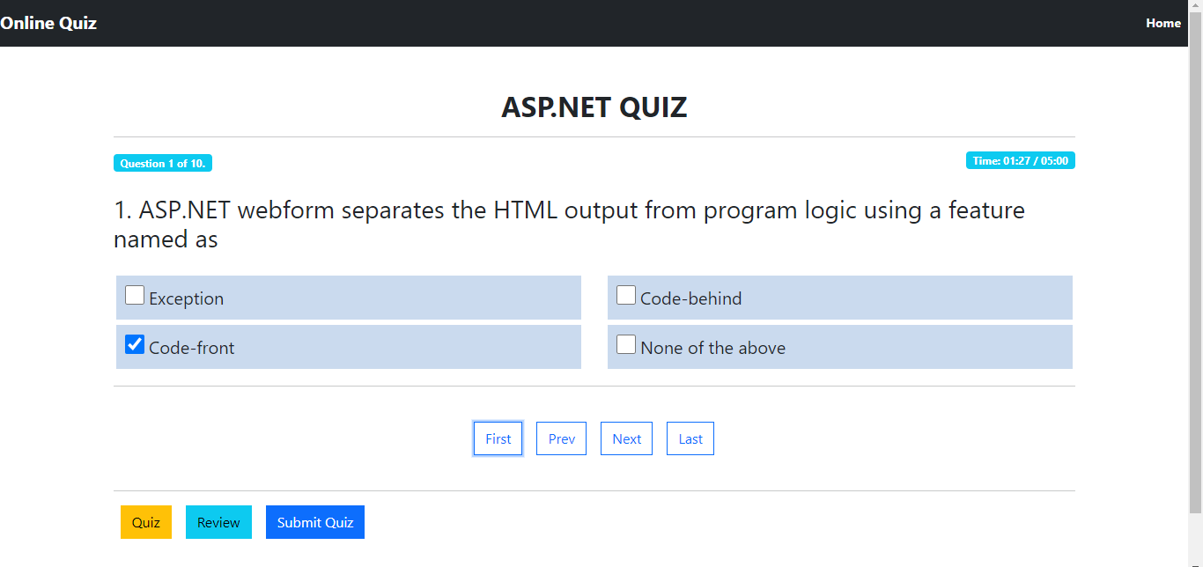

**User can select an option for the question and move to next question by clicking next navigation button**

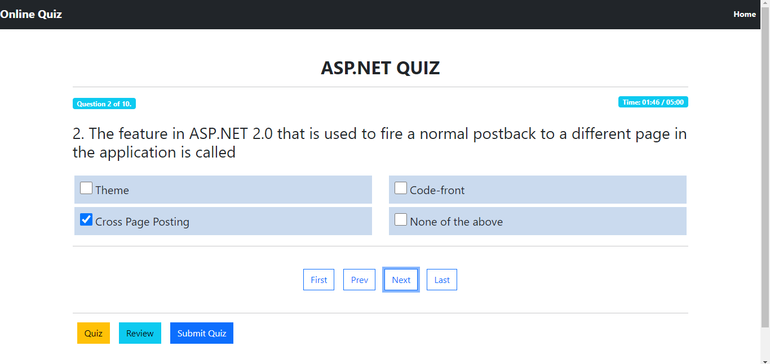

**Similarly, User can Answer all the questions asked**

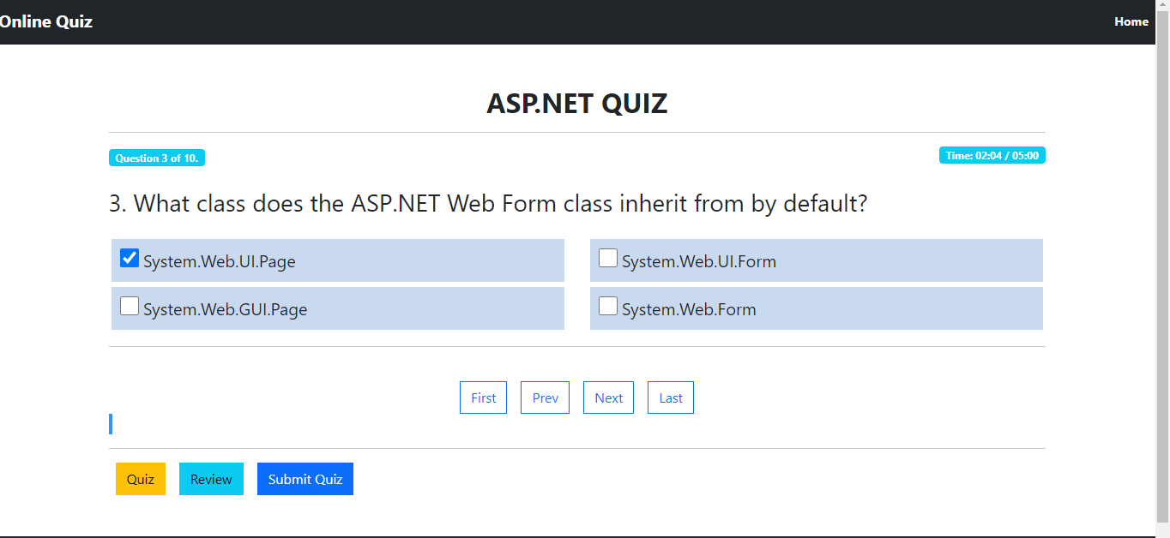

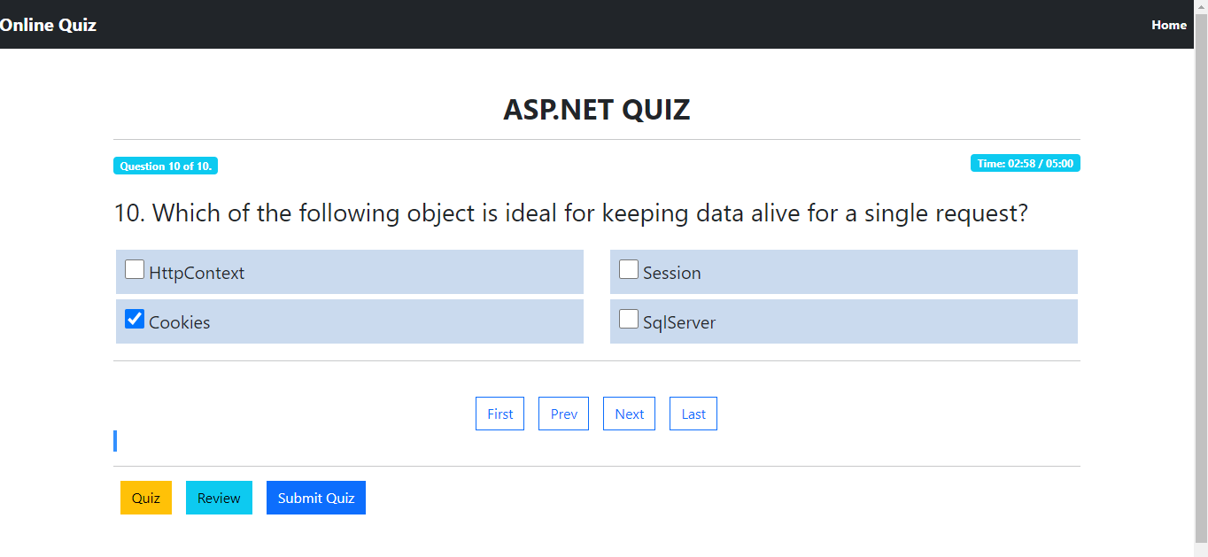

**Similarly, User can Answer all the questions asked**

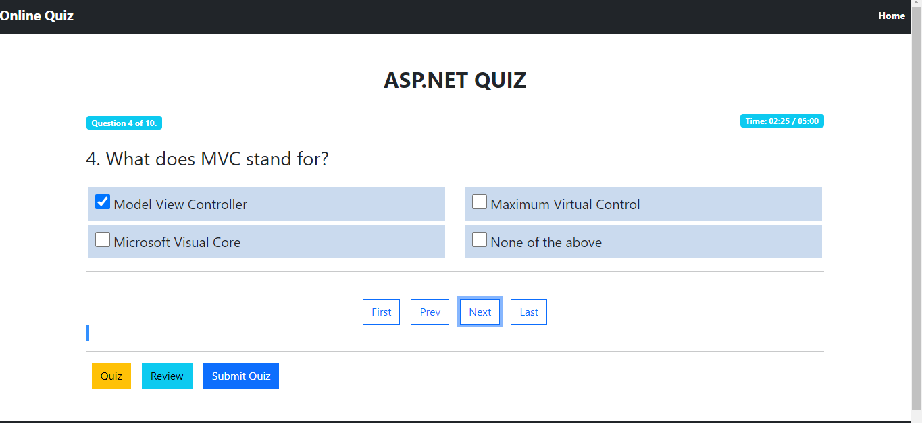

**User can also navigate to last or First question directly from First and Last Nav Links**



**User can Review All the Answered and Not Answered Questions by Clicking on Review Nav Link.**

**Also user can go to specific question to answer by clicking on any of the Question Blocks.**

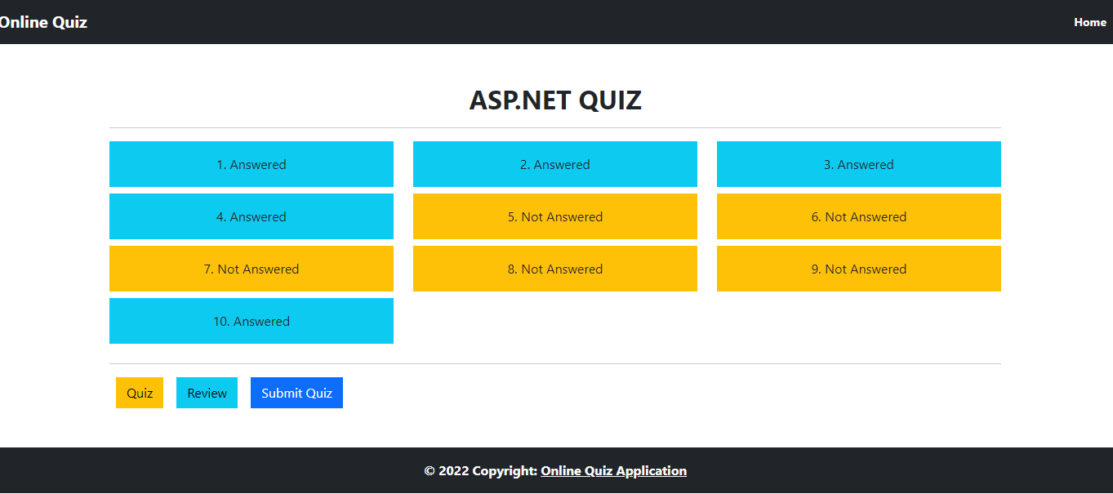

**User wanted to answer the 9th Not Answered Question:**

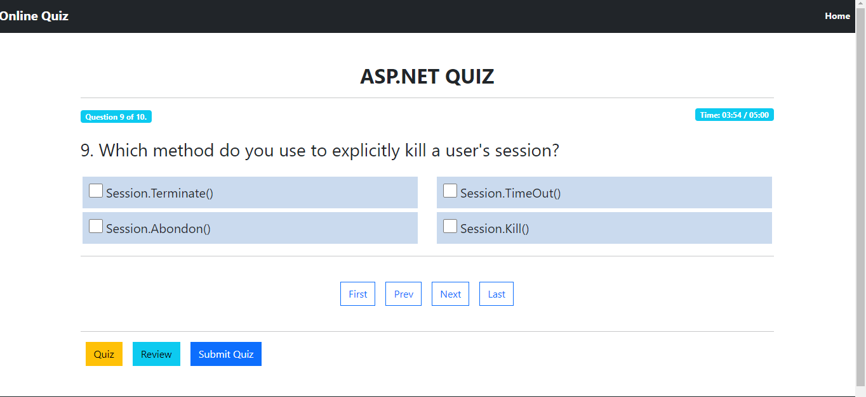

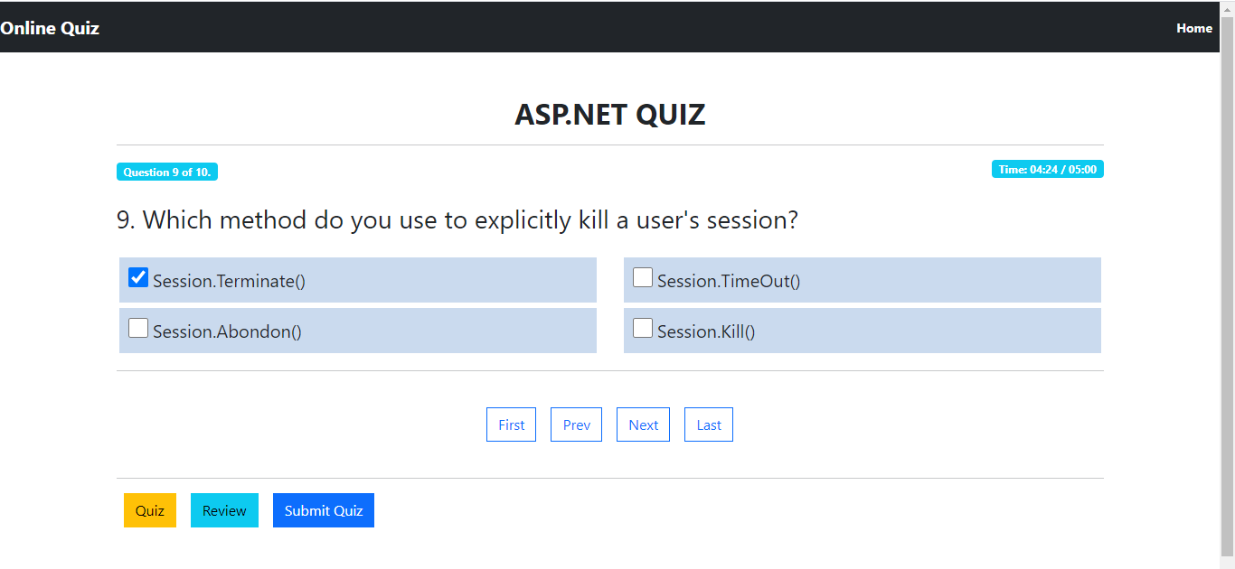

**9th  Question is Answered Now:**

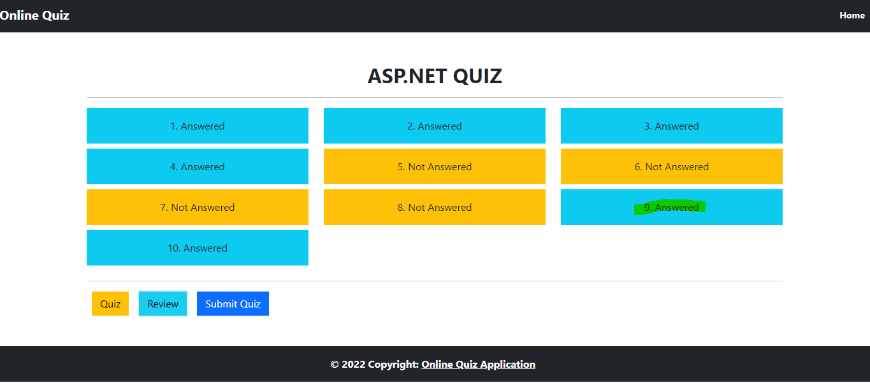

**When The user clicks on Submit button, they can see their result along with Questions and Options they have selected:**

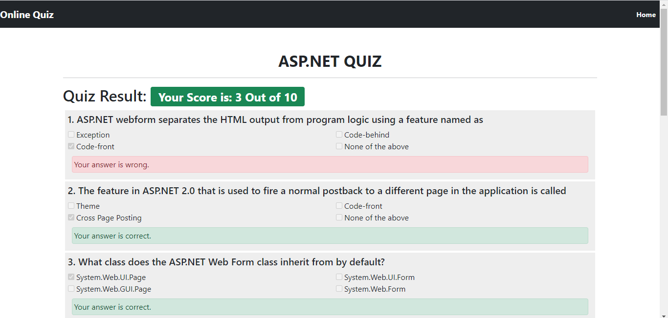

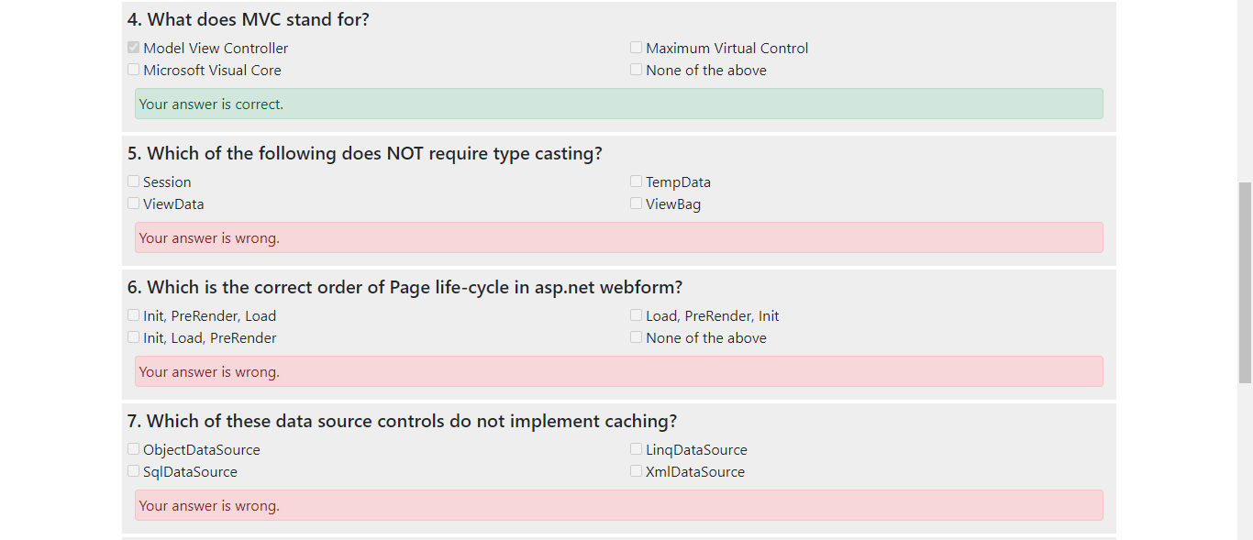

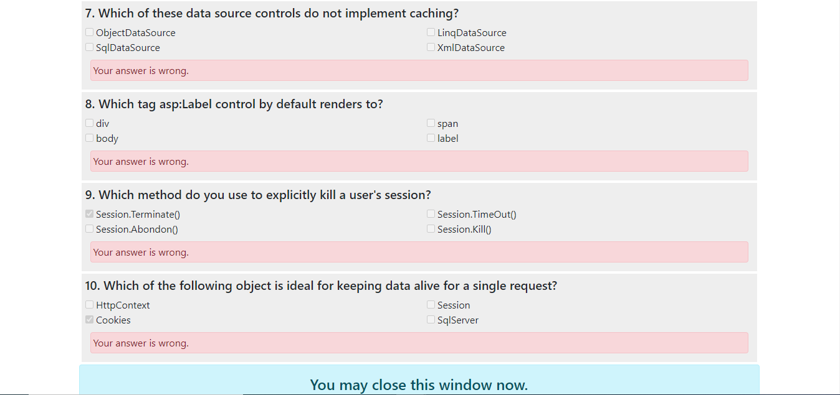

1. **User Selects to give C Sharp Quiz**



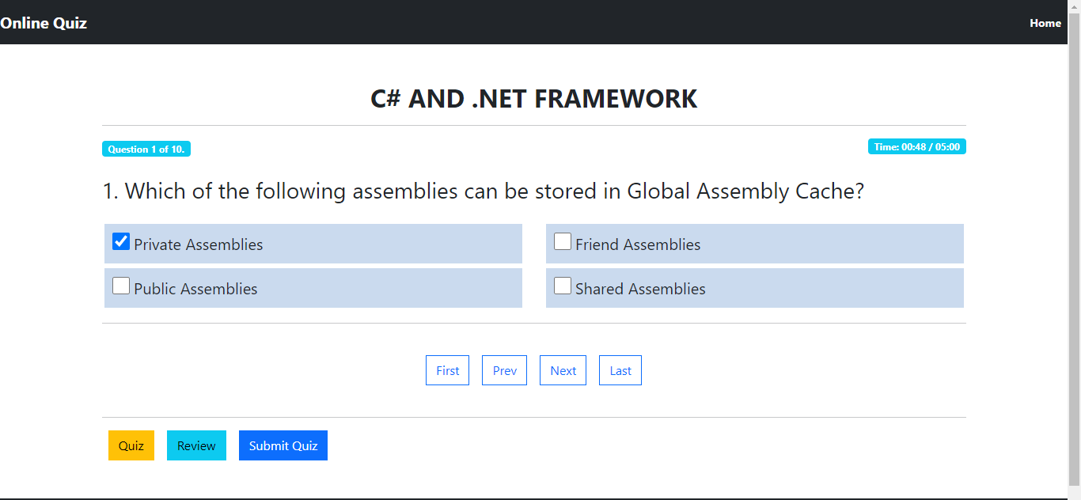

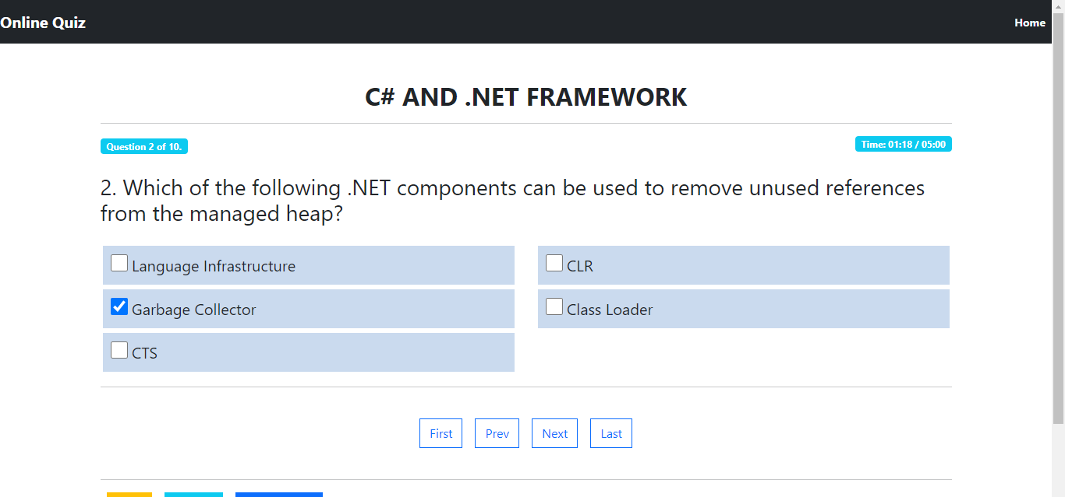

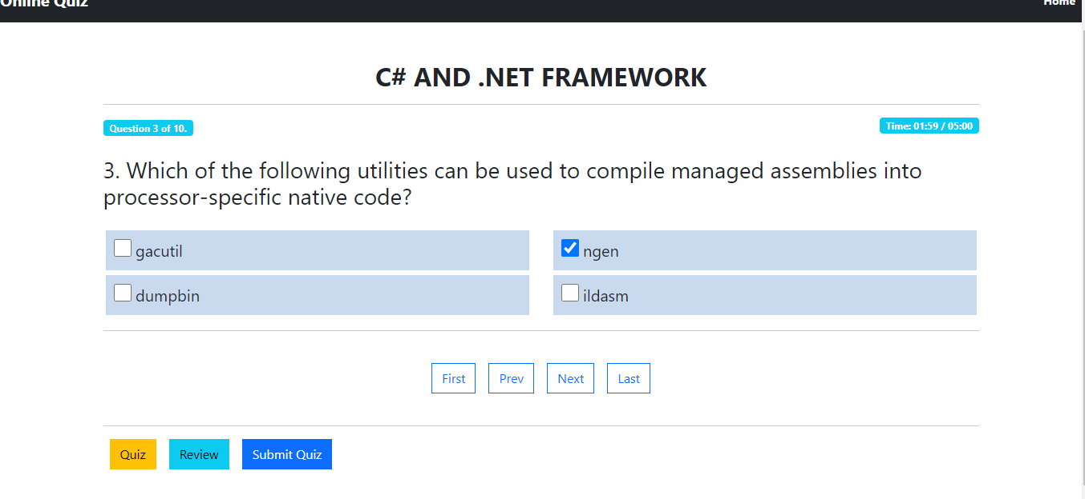

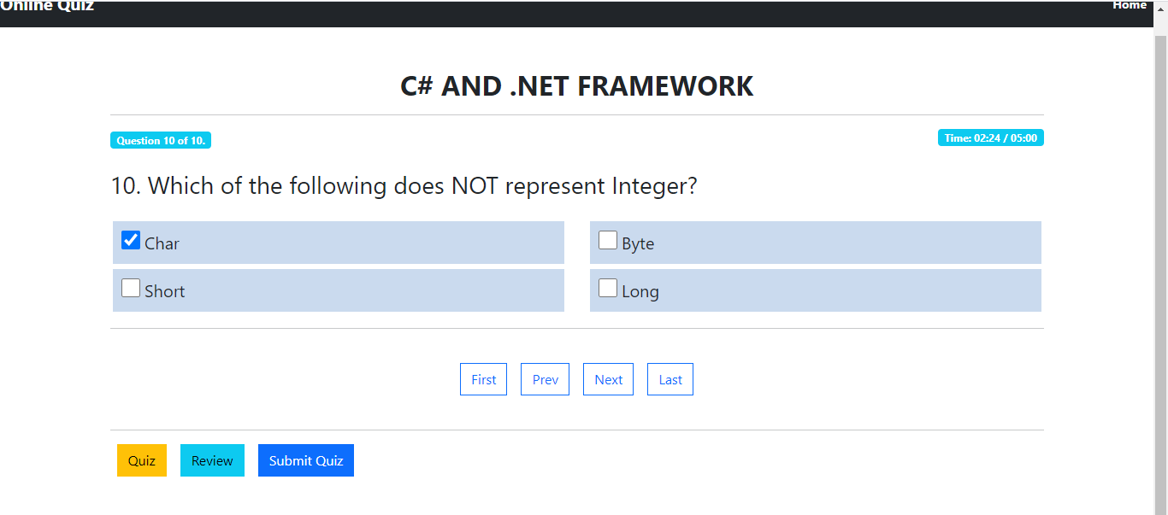

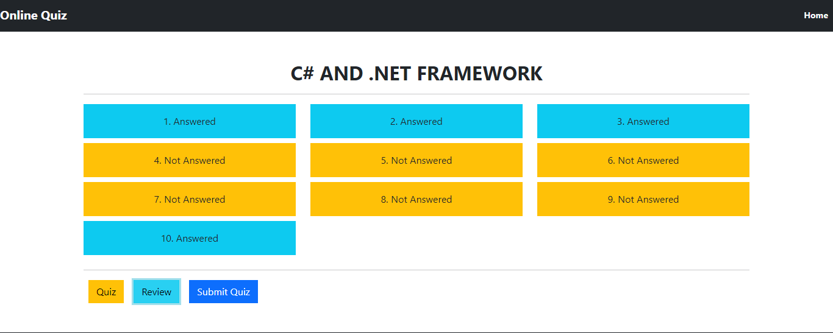

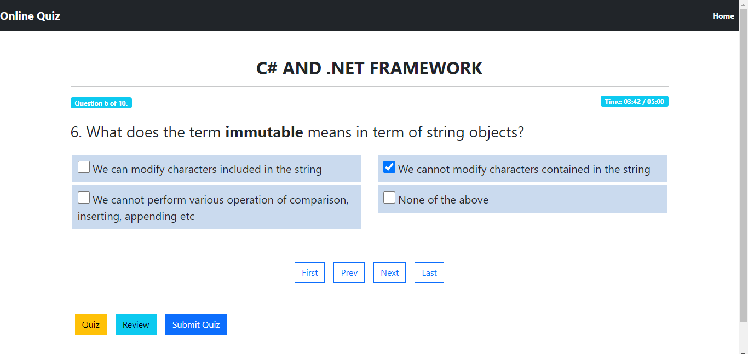

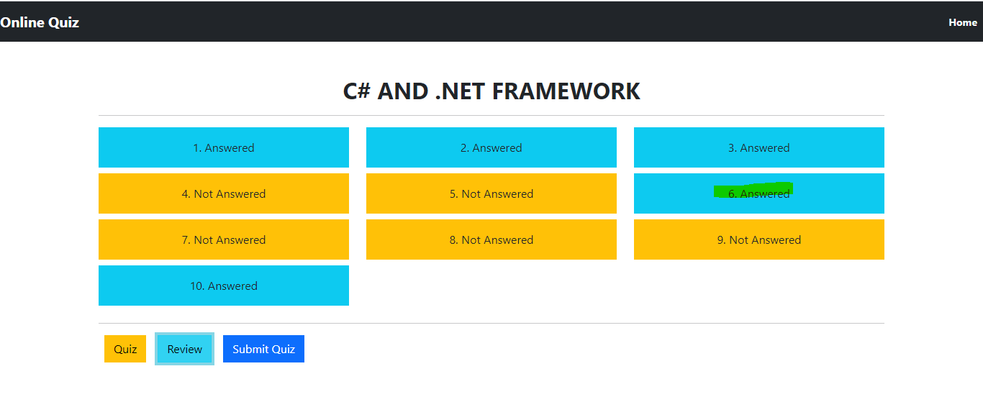

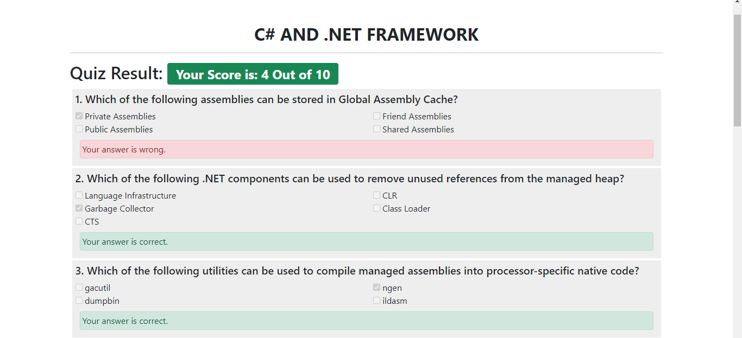

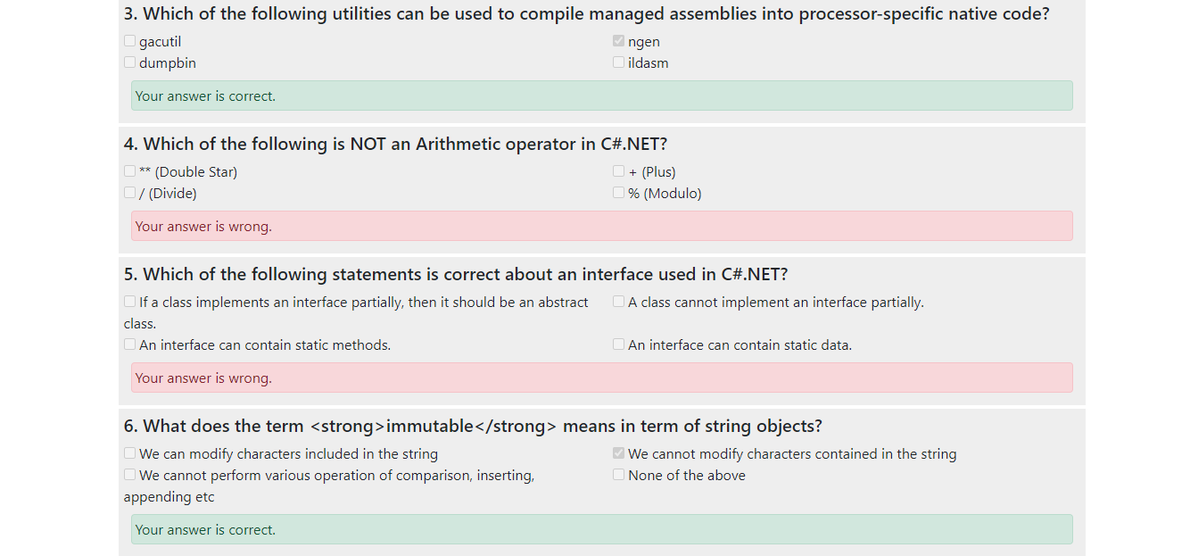

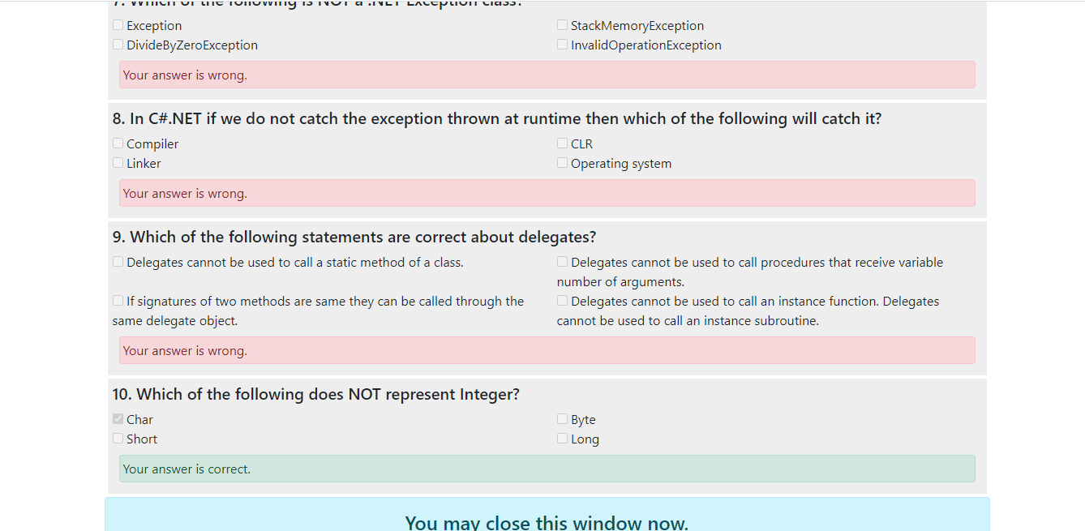

**GitHub link -** **[https://github.com/Mscitsid/](https://github.com/Mscitsid/Online-Test-Application-Quiz.git)****[Online-Test-Application-Quiz.git](https://github.com/Mscitsid/Online-Test-Application-Quiz.git)**

**Created by - Siddhant H Mhatre.**